Touchkit Driver Installation Guide for Embedded Windows XP

Touchkit driver package allows users to build the software/driver component for embedded Windows XP via Microsoft Component Designer. Then, add these touchkit software/driver components to the component database, such that the system designer can select them to add to system platform image with Microsoft Target Designer.

- Build software/driver component for Touchkit touchscreen controller.

The Microsoft Component Designer must be installed before the designer can build the software/driver packages for embedded Windows XP. Then, follow the steps showed as below to build the components.
  - Download the touchkit driver package for embedded Windows XP.
  - Setup the touchkit driver on the developing machine.
  - Launch Microsoft Component Designer. Select File->Import to import the device components from .inf file. Then, choose the INF file in the folder
under G:\Program Files\TouchKit.
a.)If you want build Serial Touchscreen component, Please import INF file
sertouch.inf. After importing sertouch.inf finished, there are 2 device
components showed as below:

    - Serial Touchscreen Controller(Professional) :
the device component for serial controller.
    - TouchScreen Enumerator :
the device component for serial controller.

PS: If you want install Serial Touchscreen Controller driver , you must
set “Serial Touchscreen Controller(Professional)” and “TouchScreen
Enumerator” both.

The screen will show the Component designer as below:
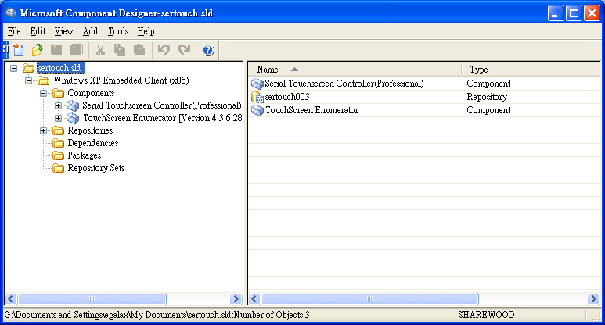
b.)If you want build USB Touchscreen component. Please import INF file
Touchkit_USB.inf. After importing Touchkit_USB.inf finished. There 2
device components show as below :

- USB Touchscreen Controller(Universal) :
the device component for USB controller with VID 0EEF and PID 0001.
- USB Touchscreen Controller(Professional) :
the device component for USB controller with VID 0EEF and PID 0002
The screen will show the Component designer as below:
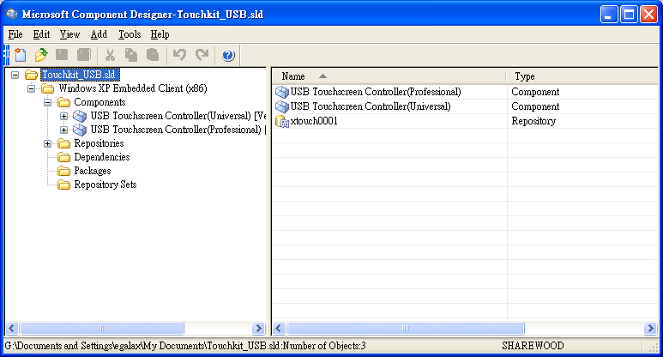

c.)If you want build PS/2 Touchscreen component. Please import INF file
Touchkit_PS2.inf. After importing Touchkit_PS2.inf finished. There a
Device component show as below :

- Touchkit Filter :
the device component for PS2 controller.

The screen will show the Component designer as below:
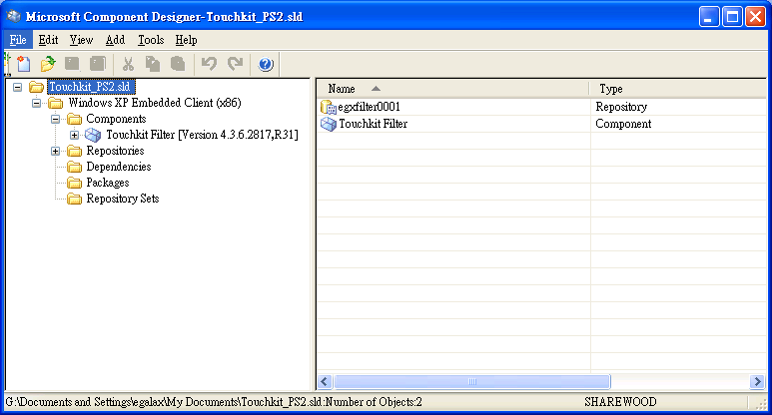

  - Create a new repository for the component.
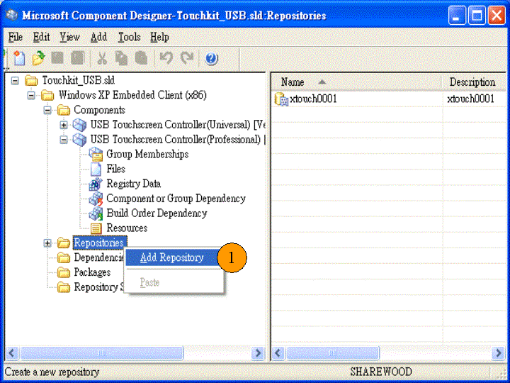

Next, the display of screen will be showed as below. The source path must be assigned to the folder where theTouchKit installed.
For example: G:\Program Files\TouchKit.
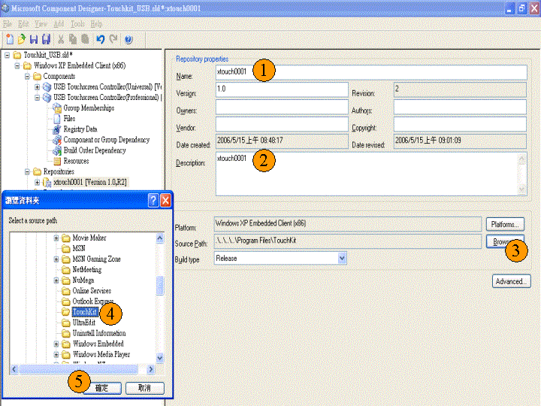
  - Set the device components.
Select the component “USB Touchscreen Controller(Universal)” for USB controller to set the properties of the component and assign the correct repository.
(if you want install RS232 Driver, you have to select “Serial Touchscreen Controller(Professional)” and “TouchScreen Enumerator” or if you want install PS2 Driver , you have to select “Touchkit Filter” )
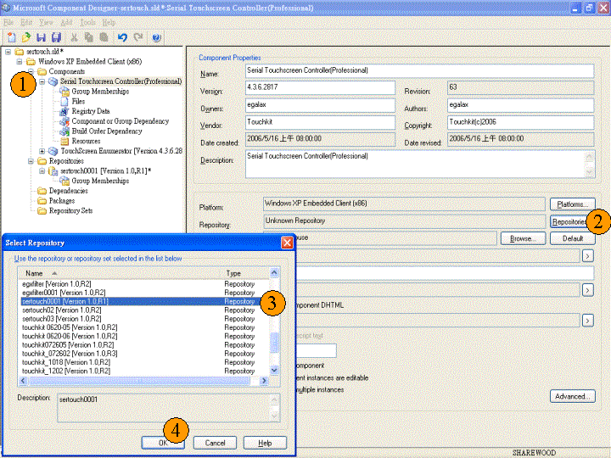

PS: If you set “TouchScreen Enumerator “device component , you must set
“Prototype” to “Device: Ports”.
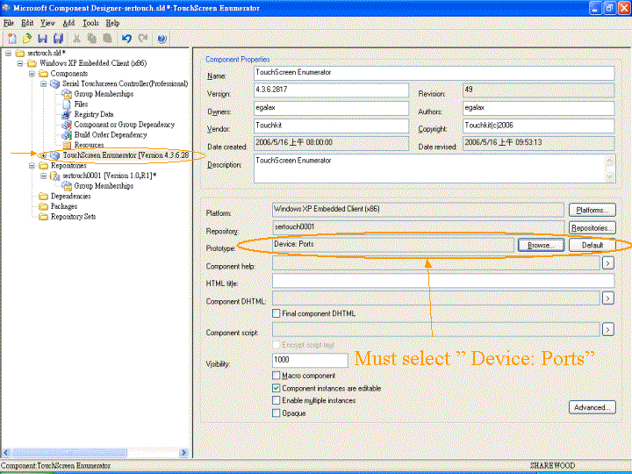
  - Add Utility files to the component.
Add the files for touchkit controller utility so that the user can do alignment or calibration and other enhanced features for touchscreen.
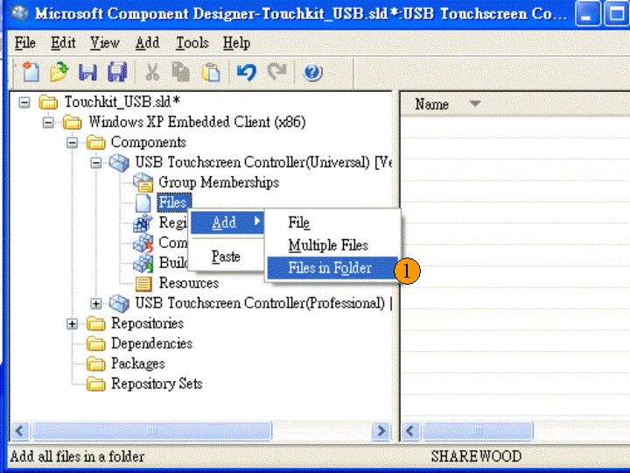
Choose the files from the repository folder
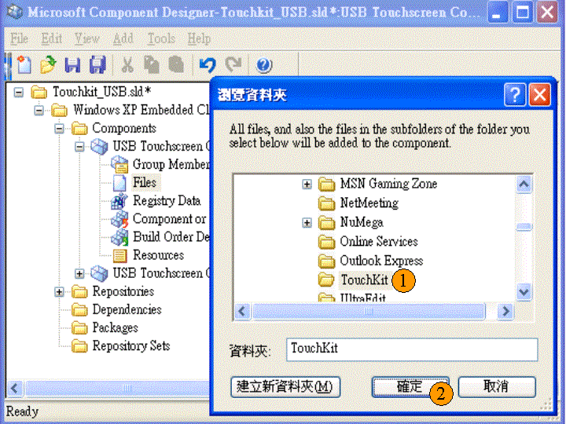

Select all of the files in the folder to add to the component.

If you want to build USB Touchscreen component , you should remove
these four files from USB Touchscreen component:
Touchkit_PS2.inf , Touchkit_PS2.cat , sertouch.inf , sertouch.cat.

If you want to build Serial Touchscreen component , you should remove
these four files from Serial Touchscreen component.
Touchkit_USB.inf , Touchkit_USB.cat ,
Touchkit_PS2.inf , Touchkit_PS2.cat

If you want to build PS/2 Touchscreen component , you should remove
these four files from PS/2 Touchscreen component.
Touchkit_USB.inf , Touchkit_USB.cat , sertouch.inf , sertouch.cat.

Add these below files again and make sure these files path to
A.) If you want to build USB Touchscreen component
a.) xAuto4PtsCal.exe %11%
b.) XTouch32Ex.dll %11%
c.) xtkutility.dll %11%
d.) Touchkit_USB.inf %17%
e.) Touchkit_USB.cat %12%
f.) xTouch.sys %12%

B.)If you want to build Serial Touchscreen component.
a.) xAuto4PtsCal.exe %11%
b.) XTouch32Ex.dll %11%
c.) xtkutility.dll %11%
e.) sertouch.inf %17%
f.) sertouch.cat %12%
g.) sertouch.sys %12%
h.) egxfilter.sys %12%
i.) xTouch.sys %12%

C.)if you want to build PS/2 Touchscreen component.
a.) xAuto4PtsCal.exe %11%
b.) XTouch32Ex.dll %11%
c.) xtkutility.dll %11%
d.) Touchkit_PS2.inf %17%
e.) Touchkit_PS2.cat %12%
f.) egxfilter.sys %12%

  - Add the registry resource for the component for some specific setting
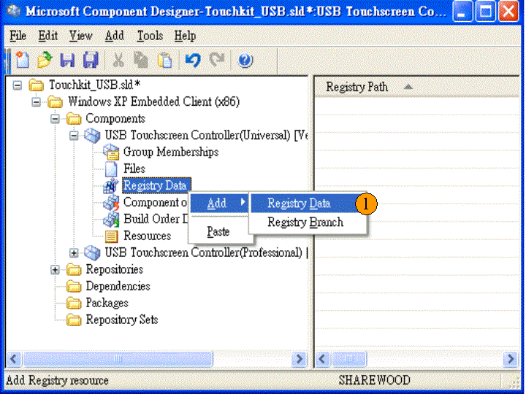

Add this registry data into component.
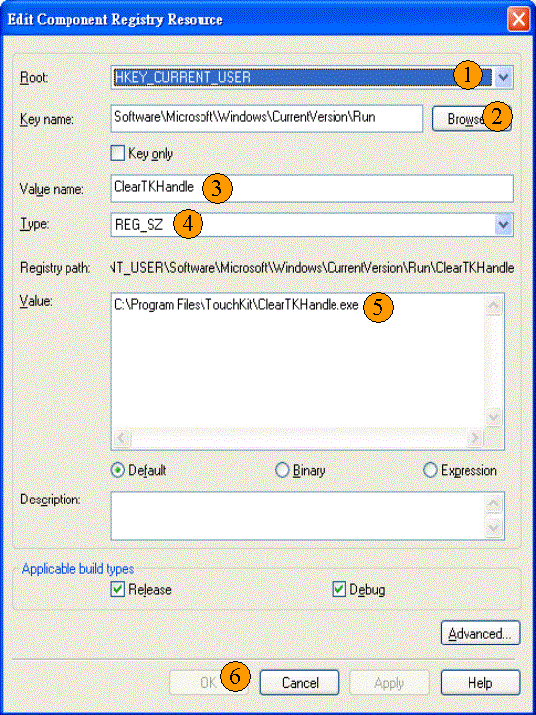

Add this registry data into component.
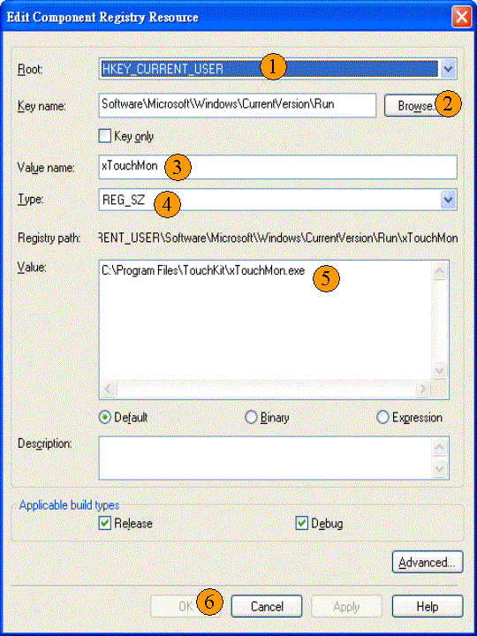

If you have set “TouchScreen Enumerator” Component , please add these
four Registry Data in “TouchScreen Enumerator” Component.

- Set Key value “ ErrorControl = 0x00000001 “
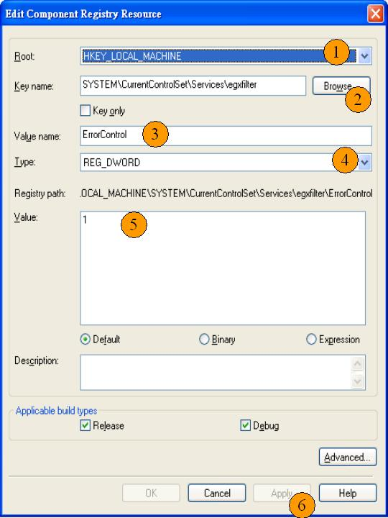

- Set Key value “ ImagePath = system32\drivers\egxfilter.sys “
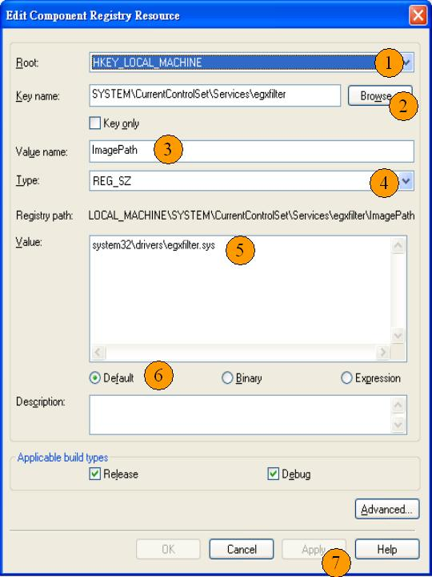

- Set Key value “ Start = 0x00000003 “
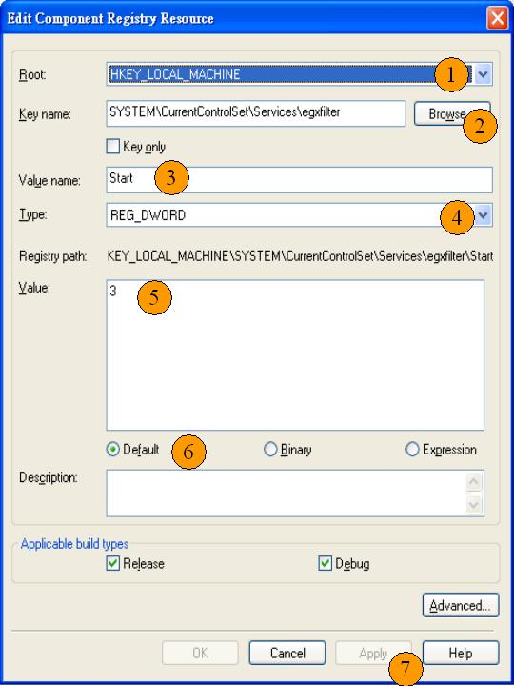

- Set Key value “ Type = 0x00000001 “
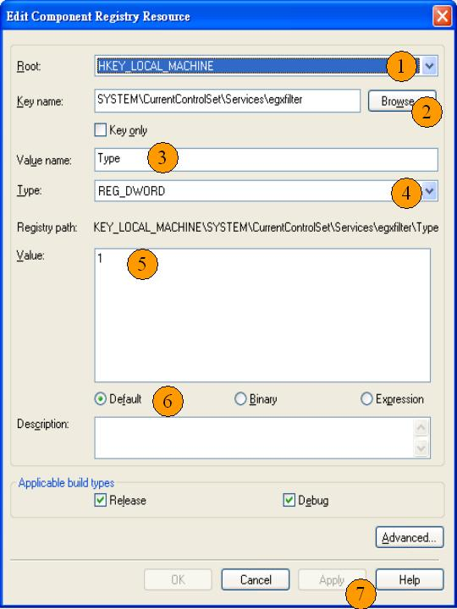

If you need to launch 4-points calibration (xAuto4PtsCal.exe)after system
first boot. Please set this Rigistry data.
( PS : You need not attach 4-points calibration for “TouchScreen Enumerator “
device component )
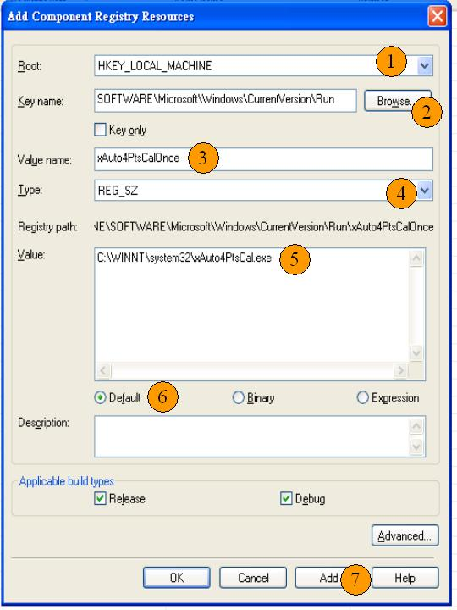

  - Modify inf file for serial controller. (Only for RS232 controller)
Edit the “sertouch.inf” in the folder G:\Program Files\TouchKit.
Locate the string “rundll32 xtouch32ex.dll, SearchSerialTouch XXX”.
Where, XXX is the string to make the system scan the specified
COM ports. For example , if xxx string is COM1 , Edit XXX string to be COM1, the system will scan COM1 for touchscreen controller only. If XXX string is COM1COM2, the system will scan both COM1 and COM2 for touchscreen at boot time.

  - Tool->Component database manager to import current SLD file to the component database.

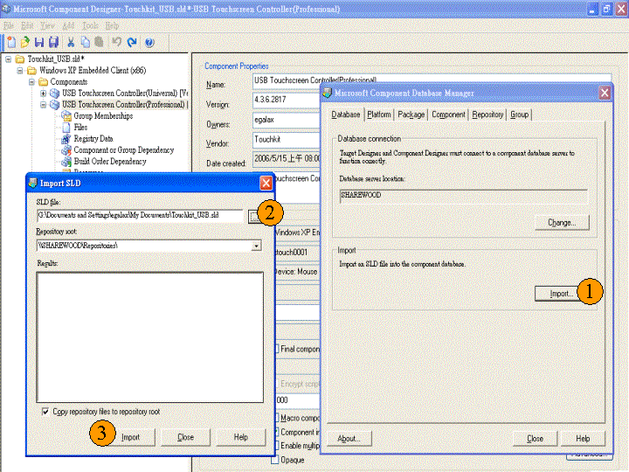

- Include the touchscreen component to the platform image
After the components were added to the component database, The component name will be shown in the folder of Hardware/”mice and other pointing devices” when the Microsoft Target Designer launched. Then, just double click on the component “USB Touchscreen Controller(Universal)” (for USB controller ) or “Serial Touchscreen Controller(Professional)” and “TouchScreen Enumerator “( for serial RS232 controller ) or “Touchkit Filter” ( for PS2 controller )to add them to the platform image.
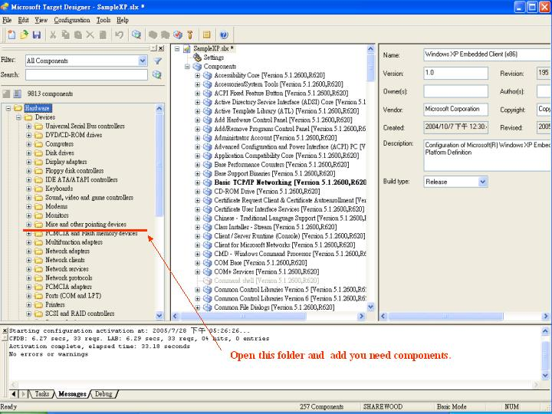

After added components , please press ‘Save’ button.
Then refer to following steps :
- Select ‘ Configuration -> Upgrade Configuration ’ to upgrade
components.
- Press ‘ Save ‘ button.
- Select ‘ Configuration -> Check Dependencies ’ .
- Select ‘ Configuration -> Build Target Image…’

The Embedded Windows XP image will be built.
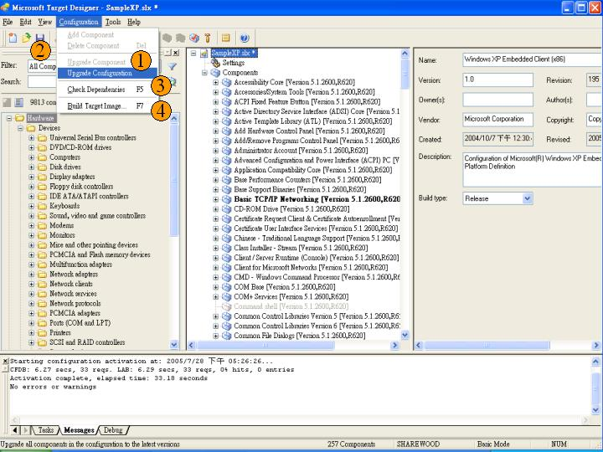

- Replace Touchscreen Default values
If you want replace Touchscreen Default values , like on/off Beep or
Enable/disable Auto right button and others.
Edit the “Touchkit_USB.inf” or ”Touchkit_PS2.inf” or “sertouch.inf”
in the folder G:\Program Files\TouchKit.
Locate the section [usb_AddReg] , [egxfilter.HW.AddReg] or
[sertouch_Inst_AddReg] . You can attach some entry in this three
sections.

example : if you want set Beep , you can attach this entry.

HKR,,"BeepMode",0x00010003,xxxxxxx

Set to 0x00000000 = Off Beep
Set to 0x00000001 = Beep when touched
Set to 0x00000002 = Beep when released

Name | Value | Description
BeepMode | 0x00000000  0x00000001  0x00000002 | Off Beep  Beep when touched  Beep when released
BeepFrequency | 0x00000064  ~0x00000FA0 | Beep Frequency
BeepDuration | 0x00000019  ~0x000001F4 | Beep duration
MouseMode | 0x80000000  0x40000000  0x20000000  0x10000000  0x00000000  0x00000001  0x00000002  0x00000003  0x00000004 | make driver to report right button.  enable auto right button feature.  disable driver to report mouse event.  Set this flag to make driver to by pass the software filter to get more fast response.  Default value of mouse emulation mode.  set the mouse emulation mode to be “Click on Touch”.  set the mouse emulation mode to be “Click on Release”.  set the mouse emulation mode to be “Click On Touch No Move”.  set the mouse emulation mode to be “click On Release No Move”.
ConstDuration | 0x00000000  ~0x00000078  ( 0 ~ 120 ) | constant touch parameter which define the touch duration in milli-second for auto right click.( 3Sec = 120 * 0.025 )
ConstRange | 0x00000020  ~0x000008C0 | constant touch parameter which define the touch range for auto right click.  ( 1 pixel = 0x00000020 >> 5)
EdgeInfo | 0x00 0x00 0x00 0x00  0x00 0x00 0x00 0x00  0x00 0x00 0x00 0x00  0x00 0x00 0x00 0x00  0x00 0x00 0x00 0x00  0x00 0x00 0x00 0x00  0x00 0x00 0x00 0x00 | lLeft (4 bytes)  Edge compensation parameter in left side.  lRight (4 bytes)  Edge compensation parameter in right side.  lTop (4 bytes)  Edge compensation parameter in upper  side  lBottom (4 bytes)  Edge compensation parameter in bottom  side  lOffsetX (4 bytes)  Offset parameter in X direction.  lOffsetY (4 bytes)  Offset parameter in Y direction.  ulMode (4 bytes)  Flag to enable/disable edge compensation. This flag must be either 0 or 1

